

**TRI - Town Centre Covid-19 Recovery Grants**

**Guidance Document**

In response to the financial impact that the Covid-19 pandemic is having on town centre businesses, Welsh Government has allocated a recovery funding package of £600,000 for Blaenau Gwent Town Centre businesses to enable trading to resume and restore consumer confidence in the Town Centre.

The Covid-19 recovery grant programme will support business owners with the purchase of equipment or modifications to premises to enable social distancing in areas of a business where customers and members of the public congregate, are served food and drink or rest.

**A limited number of grants are available to cover 80% of the cost of eligible works/ equipment (inc. installation costs and planning application fee’s) to a maximum value of £15,000 (ex VAT) per business.**

Grant payments will be made, on submission of invoices for eligible items (inc installation) agreed in advance in the applicant’s grant offer letter.

Periodic checks on grant funded items will take place to ensure items acquired under this grant programme are utilised for their intended purpose. Items purchased under the grant which are not in use or missing will result in the recovery of the grant award from the applicant.

**To register your interest – Please request a Covid 19 Recovery Pack by emailing**

[**Regeneration-projects@blaenau-gwent.gov.uk**](mailto:Regeneration-projects@blaenau-gwent.gov.uk)

**Eligible Covid-19 recovery measures include:**

**Internal shop modification – Counters/ Screens**

New or modification to existing shop counter tops are eligible to ensure the required social distance is maintained between business staff and customers. Plastic screens are encouraged to be used at paypoints and serveries where customer contact is most likely.

**Canopies / Awnings**

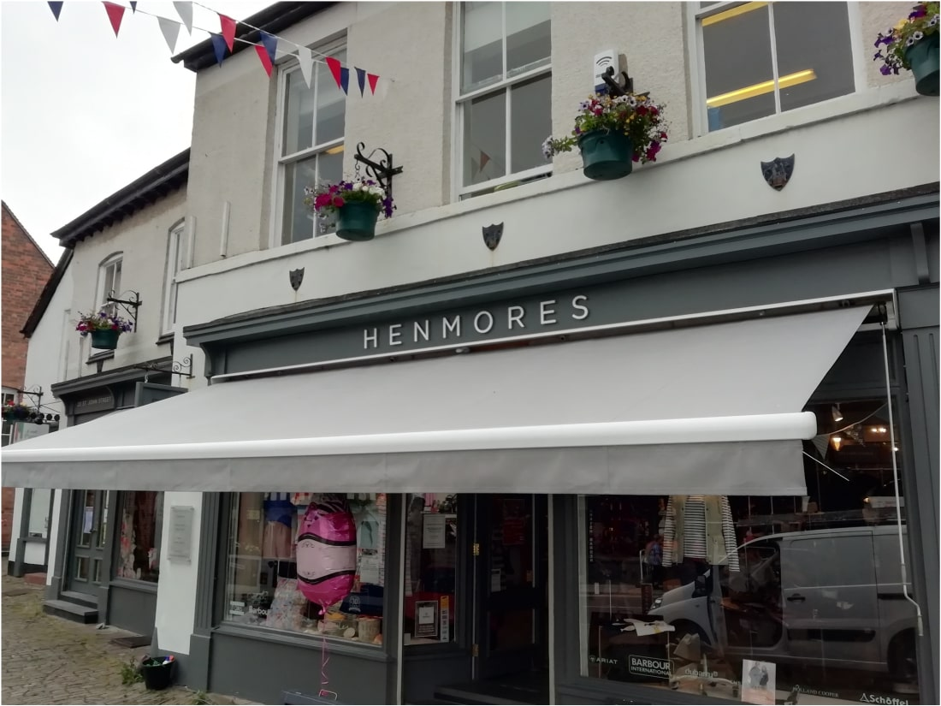

* Shop front canopies/ awnings require planning permission and should only be proposed in circumstances where they are in keeping with the age, character and architecture of a building.
* Shop front canopies must not impede pedestrians or vehicle traffic using the pavements or roads within the Town Centre and should give a minimum clearance of 2650mm above the pavement and a minimum of 1000 mm between the canopy and the kerb edge.
* Shop front canopies are required to be fixed to building frontages, have no forms of support from the public highway and of a size, proportion, position, colour and shape that complements the shopfront.
* Shop front canopies should integrate into the design of the shop frontage i.e not appear to be an obvious ‘bolt on’ feature, and should be fully retractable into the façade of the shopfront or discreet box housing. Non-retractable ‘fixed’ canopies or ‘Dutch Style’ canopies will not be supported.
* Shop front Canopies must be self-supporting and open on three sides to allow customers protection from inclement weather whist queueing, purchasing items or dining outside and fully retracted outside of trading hours.
* Branding is permissible.
* Gazebos and marquees used in other areas should be open on four sides.
* Coverings, awnings, marquees or gazebos need to be either transparent or of light cover so as to ensure transmission of sunlight.
* Canopies and gazebos/marquees should consider the effects of sunlight, wind direction and wind intensity.
* Staff utilising the canopies should be appropriately trained in their use and it is the businesses responsibility to ensure any canopy is maintained. Regular safety inspection is to be undertaken to ensure the continual safety of members of the public.

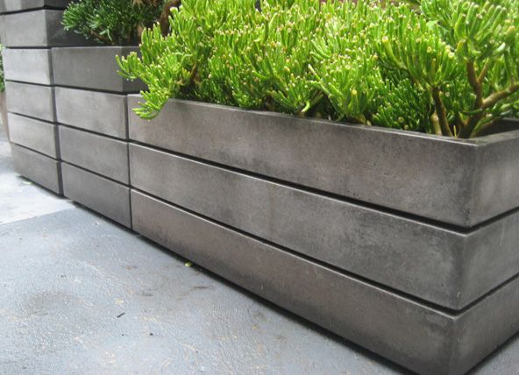**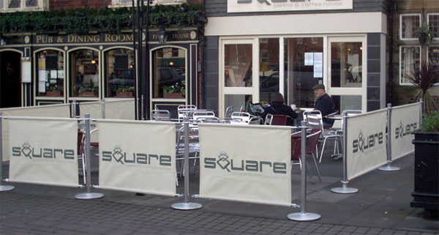Café / Pub Barrier systems / Planters**

* Café barriers should include stainless steel / chrome stanchions with a heavy canvas/ plastic banner.
* Barriers should segregate diners from pedestrians not impede pedestrians or vehicles in the town centre.
* Segregated areas should be regularly supervised to ensure guidance social distancing is followed.
* Barriers must be removable and returned to shop premises outside of trading hours.
* Branding on the canvas/ plastic banners is permissible.
* Large planters are encouraged to enhance the aesthetics of seating areas and ensure social distancing is observed but must be removed after trading hours. The consent of BGCBC as the Highway Authority will be required*.*

***( Please liaise with Grants Officer for advice)***

**Outdoor Heaters (Gas or Infrared)**

[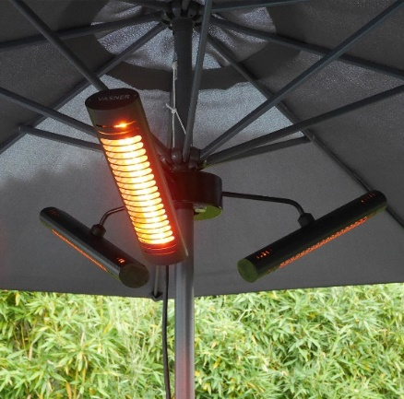](https://www.vasner.com/wp-content/uploads/2019/10/Parasol-heater-VASNER-Umbrella-X30-black.jpg)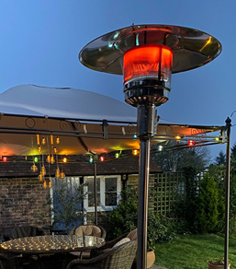

* Outdoor Heaters can be free standing or fixed to buildings or non-flammable awnings and parasols.
* Outdoor Heaters will not be permitted on the public highway as they present a hazard to members of the public.
* **The consent of BGCBC as the Highway Authority will be required*.***

***(Please liaise with Grants Officer for advice)***

**Outdoor serveries / Table & Chairs / Outdoor Lighting**

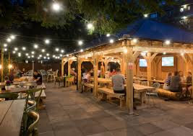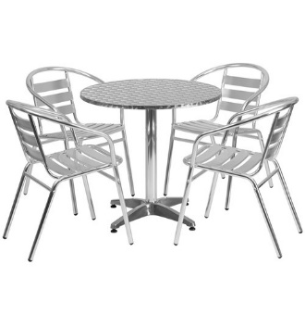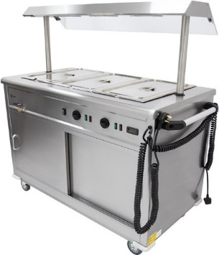

* Outdoor servery’s (including the necessary electrical and utilities connections) are eligible for food and drink retailers as these will facilitate open air trading space and compliment any outdoor dining / seating areas.
* Table and chairs are required to add amenity to the outdoor areas therefore inexpensive plastic seating is discouraged and will not be eligible for funding. A Furniture style that is practical and elegant, and integrates well with the surrounding townscape is encouraged - Seating layouts should observe the current Welsh Government guidance on social distancing requirements.
* Small ‘green infrastructure’ schemes to accommodate additional seating space are also eligible. i.e. utilising garden areas for dining space.
* Additional lighting and outdoor electrical connections are eligible as this will enhance any usable outdoor leisure or dining space and encourage its use by customers.
* Outdoor areas should be regularly supervised to avoid crowding and ensure Welsh Government guidance on social distancing is observed.

**Hand sanitiser dispensers**

* Soap / alcohol gel dispensers are deemed eligible as these will encourage customers to comply with Welsh Government guidance on the need for regular hand sanitising to limit the spread of Coronavirus. Hand sanitiser stations are encouraged on entrance to the premises and can be wall mounted or free standing.